Лабораторная работа №5.1

**Цель работы:** Дисперсионный анализ (ANOVA)

#### 

1. ANOVA;
2. ANOVA;
3. ANOVA;
4. ANCOVA!

### Загрузим данные

data = read.csv("https://raw.githubusercontent.com/SergeyMirvoda/MD-DA-2017/master/data/diet.csv", row.names = 1)  
summary(data)

## gender Age Height pre.weight   
## Min. :0.0000 Min. :16.00 Min. :141.0 Min. : 58.00   
## 1st Qu.:0.0000 1st Qu.:32.25 1st Qu.:164.2 1st Qu.: 66.00   
## Median :0.0000 Median :39.00 Median :169.5 Median : 72.00   
## Mean :0.4342 Mean :39.15 Mean :170.8 Mean : 72.53   
## 3rd Qu.:1.0000 3rd Qu.:46.75 3rd Qu.:174.8 3rd Qu.: 78.00   
## Max. :1.0000 Max. :60.00 Max. :201.0 Max. :103.00   
## NA's :2   
## Diet weight6weeks   
## Min. :1.000 Min. : 53.00   
## 1st Qu.:1.000 1st Qu.: 61.85   
## Median :2.000 Median : 68.95   
## Mean :2.038 Mean : 68.68   
## 3rd Qu.:3.000 3rd Qu.: 73.83   
## Max. :3.000 Max. :103.00   
##

Ознакомимся со структурой и переименуем колонки, как нам удобно

colnames(data) <- c("gender", "age", "height", "initial.weight",  
 "diet.type", "final.weight")  
data$diet.type <- factor(c("A", "B", "C")[data$diet.type])

Добавим новую колонку - Похудение

data$weight.loss = data$initial.weight - data$final.weight

Проанализиуем есть ли различия по типам диет

boxplot(weight.loss ~ diet.type, data = data, col = "light gray",  
 ylab = "Weight loss (kg)", xlab = "Diet type")  
abline(h = 0, col = "green")

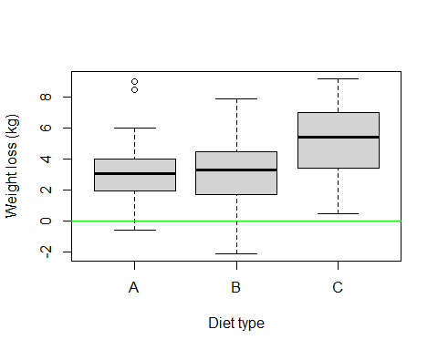

проверим сбалансированные ли данные

table(data$diet.type)

##   
## A B C   
## 24 27 27

plotmeans(weight.loss ~ diet.type, data = data)

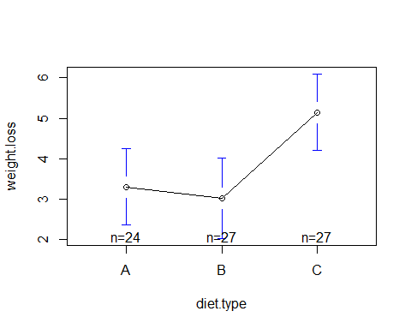

aggregate(data$weight.loss, by = list(data$diet.type), FUN = sd)

## Group.1 x  
## 1 A 2.240148  
## 2 B 2.523367  
## 3 C 2.395568

Tест на межгрупповые различия

fit <- aov(weight.loss ~ diet.type, data = data)  
summary(fit)

## Df Sum Sq Mean Sq F value Pr(>F)   
## diet.type 2 71.1 35.55 6.197 0.00323 **  
## Residuals 75 430.2 5.74   
## ---  
## Signif. codes: 0 '***' 0.001 '**' 0.01 '*' 0.05 '.' 0.1 ' ' 1

попарные различия между средними значениями для всех групп

TukeyHSD(fit)

## Tukey multiple comparisons of means  
## 95% family-wise confidence level  
##   
## Fit: aov(formula = weight.loss ~ diet.type, data = data)  
##   
## $diet.type  
## diff lwr upr p adj  
## B-A -0.2740741 -1.8806155 1.332467 0.9124737  
## C-A 1.8481481 0.2416067 3.454690 0.0201413  
## C-B 2.1222222 0.5636481 3.680796 0.0047819

par(mar = c(5, 4, 6, 2))  
tuk <- glht(fit, linfct = mcp(diet.type = "Tukey"))  
plot(cld(tuk, level = .05), col = "lightgrey")

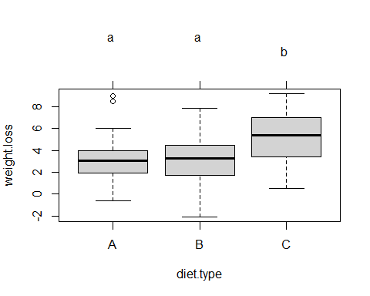

### Добавить проверку на выборы и избавиться от них

plot(data$weight.loss, data$diet.type)

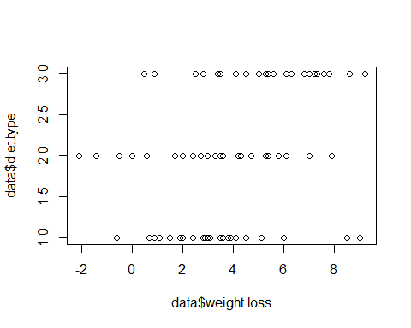

data.noout <- data[data$weight.loss > 0,]  
plot(data.noout$weight.loss, data.noout$diet.type)

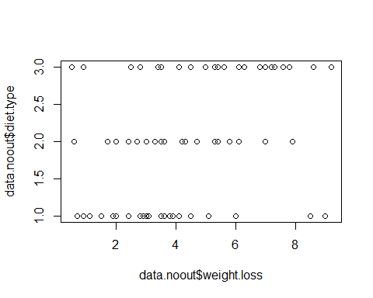

### повторно проверсти все тесты и сравнить результаты с выбросами и без

table(data.noout$diet.type)

##   
## A B C   
## 23 22 27

plotmeans(weight.loss ~ diet.type, data = data.noout)

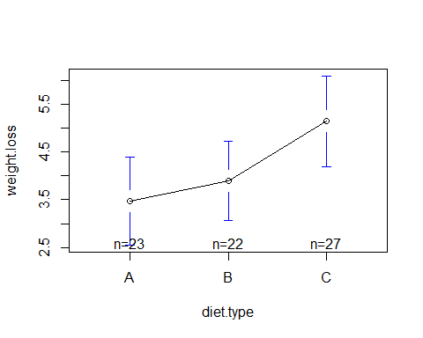

fit <- aov(weight.loss ~ diet.type, data = data.noout)  
summary(fit)

## Df Sum Sq Mean Sq F value Pr(>F)   
## diet.type 2 38.5 19.262 4.139 0.0201 *  
## Residuals 69 321.1 4.653   
## ---  
## Signif. codes: 0 '***' 0.001 '**' 0.01 '*' 0.05 '.' 0.1 ' ' 1

TukeyHSD(fit)

## Tukey multiple comparisons of means  
## 95% family-wise confidence level  
##   
## Fit: aov(formula = weight.loss ~ diet.type, data = data.noout)  
##   
## $diet.type  
## diff lwr upr p adj  
## B-A 0.4258893 -1.1149787 1.966757 0.7861657  
## C-A 1.6785829 0.2124490 3.144717 0.0209348  
## C-B 1.2526936 -0.2313247 2.736712 0.1145630

tuk <- glht(fit, linfct = mcp(diet.type = "Tukey"))  
plot(cld(tuk, level = .05), col = "lightgrey")

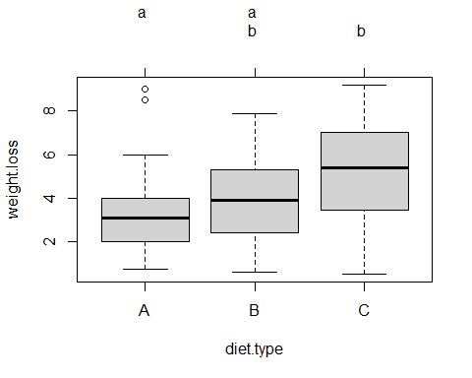

Удаление выбросов не повлияло на диету-победителя - Диета С всё так же заметно лучше двух других. Однако, по результатам сравнения на данных без выбросов, диета В заняла 2 место! Таким образом, выбросы, приводят к досадным ошибкам и могут повлиять на репутацию компании...

### Задания из документа

Are there gender differences for weight lost?

data.noout$gender <- factor(c("Female", "Male")[as.ordered(data.noout$gender)])  
  
boxplot(weight.loss ~ gender, data = data.noout, col = "light gray",  
 ylab = "Weight loss (kg)", xlab = "Gender")

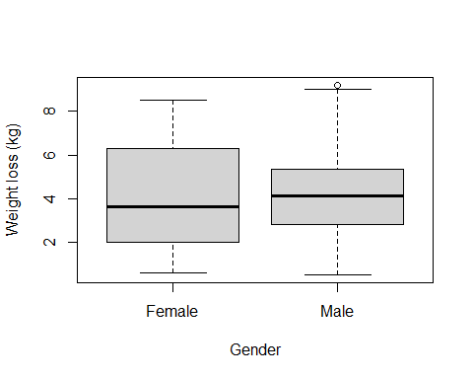

plotmeans(weight.loss ~ gender, data = data.noout)

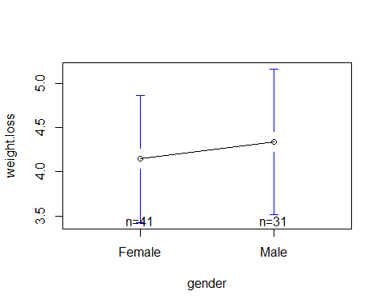

aggregate(data.noout$weight.loss, by = list(data.noout$gender), FUN = sd)

## Group.1 x  
## 1 Female 2.280362  
## 2 Male 2.243015

Effect of diet and gender on weight lost? Means plot of weight lost by diet and gender

data.noout$typebygender <- interaction(data.noout$diet.type, data.noout$gender)  
fit <- aov(weight.loss ~ typebygender, data = data.noout)  
summary(fit)

## Df Sum Sq Mean Sq F value Pr(>F)   
## typebygender 5 73.61 14.723 3.398 0.0086 **  
## Residuals 66 285.97 4.333   
## ---  
## Signif. codes: 0 '***' 0.001 '**' 0.01 '*' 0.05 '.' 0.1 ' ' 1

TukeyHSD(fit)

## Tukey multiple comparisons of means  
## 95% family-wise confidence level  
##   
## Fit: aov(formula = weight.loss ~ typebygender, data = data.noout)  
##   
## $typebygender  
## diff lwr upr p adj  
## B.Female-A.Female 0.2083333 -2.1951757 2.6118423 0.9998482  
## C.Female-A.Female 2.8300000 0.5595964 5.1004036 0.0064413  
## A.Male-A.Female 1.0722222 -1.5380895 3.6825339 0.8325890  
## B.Male-A.Female 1.6100000 -0.9196202 4.1396202 0.4306447  
## C.Male-A.Female 1.1833333 -1.2201757 3.5868423 0.6996318  
## C.Female-B.Female 2.6216667 0.2554236 4.9879097 0.0213839  
## A.Male-B.Female 0.8638889 -1.8301973 3.5579751 0.9342180  
## B.Male-B.Female 1.4016667 -1.2143134 4.0176468 0.6191362  
## C.Male-B.Female 0.9750000 -1.5192392 3.4692392 0.8595838  
## A.Male-C.Female -1.7577778 -4.3338169 0.8182614 0.3518914  
## B.Male-C.Female -1.2200000 -3.7142392 1.2742392 0.7053894  
## C.Male-C.Female -1.6466667 -4.0129097 0.7195764 0.3301372  
## B.Male-A.Male 0.5377778 -2.2693958 3.3449513 0.9930926  
## C.Male-A.Male 0.1111111 -2.5829751 2.8051973 0.9999962  
## C.Male-B.Male -0.4266667 -3.0426468 2.1893134 0.9967497

tuk <- glht(fit, linfct = mcp(typebygender = "Tukey"))  
plot(cld(tuk, level = .05), col = "lightgrey")

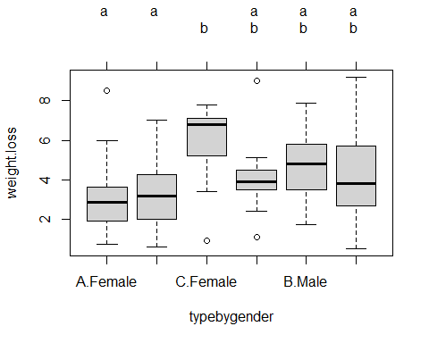

Add height to either ANOVA

data.noout$height <- cut(data.noout$height, 3, labels = c('small', 'mid', 'tall'))  
  
fit <- aov(weight.loss ~ typebygender * height, data = data.noout)  
summary(fit)

## Df Sum Sq Mean Sq F value Pr(>F)   
## typebygender 5 73.61 14.723 3.106 0.0152 *  
## height 2 2.34 1.168 0.246 0.7825   
## typebygender:height 8 18.20 2.275 0.480 0.8653   
## Residuals 56 265.44 4.740   
## ---  
## Signif. codes: 0 '***' 0.001 '**' 0.01 '*' 0.05 '.' 0.1 ' ' 1

TukeyHSD(fit)

## Tukey multiple comparisons of means  
## 95% family-wise confidence level  
##   
## Fit: aov(formula = weight.loss ~ typebygender * height, data = data.noout)  
##   
## $typebygender  
## diff lwr upr p adj  
## B.Female-A.Female 0.2083333 -2.3188741 2.7355408 0.9998772  
## C.Female-A.Female 2.8300000 0.4427483 5.2172517 0.0113572  
## A.Male-A.Female 1.0722222 -1.6724311 3.8168756 0.8568778  
## B.Male-A.Female 1.6100000 -1.0498091 4.2698091 0.4828188  
## C.Male-A.Female 1.1833333 -1.3438741 3.7105408 0.7376689  
## C.Female-B.Female 2.6216667 0.1336431 5.1096902 0.0332832  
## A.Male-B.Female 0.8638889 -1.9688505 3.6966283 0.9449367  
## B.Male-B.Female 1.4016667 -1.3489469 4.1522802 0.6634043  
## C.Male-B.Female 0.9750000 -1.6476071 3.5976071 0.8805457  
## A.Male-C.Female -1.7577778 -4.4663947 0.9508392 0.4041350  
## B.Male-C.Female -1.2200000 -3.8426071 1.4026071 0.7429200  
## C.Male-C.Female -1.6466667 -4.1346902 0.8413569 0.3819982  
## B.Male-A.Male 0.5377778 -2.4138691 3.4894247 0.9943505  
## C.Male-A.Male 0.1111111 -2.7216283 2.9438505 0.9999969  
## C.Male-B.Male -0.4266667 -3.1772802 2.3239469 0.9973514  
##   
## $height  
## diff lwr upr p adj  
## mid-small 0.2551683 -1.383685 1.894021 0.9255747  
## tall-small -0.1184965 -2.265857 2.028864 0.9903180  
## tall-mid -0.3736648 -2.125836 1.378506 0.8651271  
##   
## $`typebygender:height`  
## diff lwr upr p adj  
## B.Female:small-A.Female:small -0.10000000 -9.8482256 9.6482256 1.0000000  
## C.Female:small-A.Female:small 2.71666667 -3.7821504 9.2154837 0.9845260  
## A.Male:small-A.Female:small -0.80000000 -8.7593929 7.1593929 1.0000000  
## B.Male:small-A.Female:small 1.90000000 -7.8482256 11.6482256 0.9999992  
## C.Male:small-A.Female:small -0.90000000 -10.6482256 8.8482256 1.0000000  
## A.Female:mid-A.Female:small -0.61000000 -6.7753192 5.5553192 1.0000000  
## B.Female:mid-A.Female:small -0.14545455 -6.2638885 5.9729794 1.0000000  
## C.Female:mid-A.Female:small 2.32222222 -3.8999214 8.5443659 0.9952429  
## A.Male:mid-A.Female:small 1.33333333 -5.1654837 7.8321504 0.9999982  
## B.Male:mid-A.Female:small 2.35000000 -5.6093929 10.3093929 0.9997129  
## C.Male:mid-A.Female:small 1.15000000 -5.0153192 7.3153192 0.9999996  
## A.Female:tall-A.Female:small 0.60000000 -7.3593929 8.5593929 1.0000000  
## B.Female:tall-A.Female:small NA NA NA NA  
## C.Female:tall-A.Female:small NA NA NA NA  
## A.Male:tall-A.Female:small 0.10000000 -9.6482256 9.8482256 1.0000000  
## B.Male:tall-A.Female:small 0.85714286 -5.5245688 7.2388545 1.0000000  
## C.Male:tall-A.Female:small -0.60000000 -10.3482256 9.1482256 1.0000000  
## C.Female:small-B.Female:small 2.81666667 -5.7804602 11.4137936 0.9989440  
## A.Male:small-B.Female:small -0.70000000 -10.4482256 9.0482256 1.0000000  
## B.Male:small-B.Female:small 2.00000000 -9.2562814 13.2562814 0.9999998  
## C.Male:small-B.Female:small -0.80000000 -12.0562814 10.4562814 1.0000000  
## A.Female:mid-B.Female:small -0.51000000 -8.8578817 7.8378817 1.0000000  
## B.Female:mid-B.Female:small -0.04545455 -8.3587693 8.2678602 1.0000000  
## C.Female:mid-B.Female:small 2.42222222 -5.9677146 10.8121590 0.9997853  
## A.Male:mid-B.Female:small 1.43333333 -7.1637936 10.0304602 0.9999999  
## B.Male:mid-B.Female:small 2.45000000 -7.2982256 12.1982256 0.9999669  
## C.Male:mid-B.Female:small 1.25000000 -7.0978817 9.5978817 1.0000000  
## A.Female:tall-B.Female:small 0.70000000 -9.0482256 10.4482256 1.0000000  
## B.Female:tall-B.Female:small NA NA NA NA  
## C.Female:tall-B.Female:small NA NA NA NA  
## A.Male:tall-B.Female:small 0.20000000 -11.0562814 11.4562814 1.0000000  
## B.Male:tall-B.Female:small 0.95714286 -7.5518061 9.4660918 1.0000000  
## C.Male:tall-B.Female:small -0.50000000 -11.7562814 10.7562814 1.0000000  
## A.Male:small-C.Female:small -3.51666667 -10.0154837 2.9821504 0.8667316  
## B.Male:small-C.Female:small -0.81666667 -9.4137936 7.7804602 1.0000000  
## C.Male:small-C.Female:small -3.61666667 -12.2137936 4.9804602 0.9835356  
## A.Female:mid-C.Female:small -3.32666667 -7.4368795 0.7835461 0.2551423  
## B.Female:mid-C.Female:small -2.86212121 -6.9016661 1.1774237 0.4772824  
## C.Female:mid-C.Female:small -0.39444444 -4.5894128 3.8005239 1.0000000  
## A.Male:mid-C.Female:small -1.38333333 -5.9786910 3.2120243 0.9996318  
## B.Male:mid-C.Female:small -0.36666667 -6.8654837 6.1321504 1.0000000  
## C.Male:mid-C.Female:small -1.56666667 -5.6768795 2.5435461 0.9940196  
## A.Female:tall-C.Female:small -2.11666667 -8.6154837 4.3821504 0.9990171  
## B.Female:tall-C.Female:small NA NA NA NA  
## C.Female:tall-C.Female:small NA NA NA NA  
## A.Male:tall-C.Female:small -2.61666667 -11.2137936 5.9804602 0.9995764  
## B.Male:tall-C.Female:small -1.85952381 -6.2877212 2.5686736 0.9838219  
## C.Male:tall-C.Female:small -3.31666667 -11.9137936 5.2804602 0.9931958  
## B.Male:small-A.Male:small 2.70000000 -7.0482256 12.4482256 0.9998758  
## C.Male:small-A.Male:small -0.10000000 -9.8482256 9.6482256 1.0000000  
## A.Female:mid-A.Male:small 0.19000000 -5.9753192 6.3553192 1.0000000  
## B.Female:mid-A.Male:small 0.65454545 -5.4638885 6.7729794 1.0000000  
## C.Female:mid-A.Male:small 3.12222222 -3.0999214 9.3443659 0.9228949  
## A.Male:mid-A.Male:small 2.13333333 -4.3654837 8.6321504 0.9989190  
## B.Male:mid-A.Male:small 3.15000000 -4.8093929 11.1093929 0.9911012  
## C.Male:mid-A.Male:small 1.95000000 -4.2153192 8.1153192 0.9993143  
## A.Female:tall-A.Male:small 1.40000000 -6.5593929 9.3593929 0.9999998  
## B.Female:tall-A.Male:small NA NA NA NA  
## C.Female:tall-A.Male:small NA NA NA NA  
## A.Male:tall-A.Male:small 0.90000000 -8.8482256 10.6482256 1.0000000  
## B.Male:tall-A.Male:small 1.65714286 -4.7245688 8.0388545 0.9999481  
## C.Male:tall-A.Male:small 0.20000000 -9.5482256 9.9482256 1.0000000  
## C.Male:small-B.Male:small -2.80000000 -14.0562814 8.4562814 0.9999714  
## A.Female:mid-B.Male:small -2.51000000 -10.8578817 5.8378817 0.9996373  
## B.Female:mid-B.Male:small -2.04545455 -10.3587693 6.2678602 0.9999754  
## C.Female:mid-B.Male:small 0.42222222 -7.9677146 8.8121590 1.0000000  
## A.Male:mid-B.Male:small -0.56666667 -9.1637936 8.0304602 1.0000000  
## B.Male:mid-B.Male:small 0.45000000 -9.2982256 10.1982256 1.0000000  
## C.Male:mid-B.Male:small -0.75000000 -9.0978817 7.5978817 1.0000000  
## A.Female:tall-B.Male:small -1.30000000 -11.0482256 8.4482256 1.0000000  
## B.Female:tall-B.Male:small NA NA NA NA  
## C.Female:tall-B.Male:small NA NA NA NA  
## A.Male:tall-B.Male:small -1.80000000 -13.0562814 9.4562814 1.0000000  
## B.Male:tall-B.Male:small -1.04285714 -9.5518061 7.4660918 1.0000000  
## C.Male:tall-B.Male:small -2.50000000 -13.7562814 8.7562814 0.9999943  
## A.Female:mid-C.Male:small 0.29000000 -8.0578817 8.6378817 1.0000000  
## B.Female:mid-C.Male:small 0.75454545 -7.5587693 9.0678602 1.0000000  
## C.Female:mid-C.Male:small 3.22222222 -5.1677146 11.6121590 0.9935143  
## A.Male:mid-C.Male:small 2.23333333 -6.3637936 10.8304602 0.9999478  
## B.Male:mid-C.Male:small 3.25000000 -6.4982256 12.9982256 0.9986973  
## C.Male:mid-C.Male:small 2.05000000 -6.2978817 10.3978817 0.9999761  
## A.Female:tall-C.Male:small 1.50000000 -8.2482256 11.2482256 1.0000000  
## B.Female:tall-C.Male:small NA NA NA NA  
## C.Female:tall-C.Male:small NA NA NA NA  
## A.Male:tall-C.Male:small 1.00000000 -10.2562814 12.2562814 1.0000000  
## B.Male:tall-C.Male:small 1.75714286 -6.7518061 10.2660918 0.9999980  
## C.Male:tall-C.Male:small 0.30000000 -10.9562814 11.5562814 1.0000000  
## B.Female:mid-A.Female:mid 0.46454545 -3.0131636 3.9422545 1.0000000  
## C.Female:mid-A.Female:mid 2.93222222 -0.7248664 6.5893109 0.2691463  
## A.Male:mid-A.Female:mid 1.94333333 -2.1668795 6.0535461 0.9523197  
## B.Male:mid-A.Female:mid 2.96000000 -3.2053192 9.1253192 0.9458192  
## C.Male:mid-A.Female:mid 1.76000000 -1.7995487 5.3195487 0.9312832  
## A.Female:tall-A.Female:mid 1.21000000 -4.9553192 7.3753192 0.9999991  
## B.Female:tall-A.Female:mid NA NA NA NA  
## C.Female:tall-A.Female:mid NA NA NA NA  
## A.Male:tall-A.Female:mid 0.71000000 -7.6378817 9.0578817 1.0000000  
## B.Male:tall-A.Female:mid 1.46714286 -2.4552888 5.3895745 0.9951271  
## C.Male:tall-A.Female:mid 0.01000000 -8.3378817 8.3578817 1.0000000  
## C.Female:mid-B.Female:mid 2.46767677 -1.1098043 6.0451578 0.5248477  
## A.Male:mid-B.Female:mid 1.47878788 -2.5607570 5.5183327 0.9961578  
## B.Male:mid-B.Female:mid 2.49545455 -3.6229794 8.6138885 0.9878884  
## C.Male:mid-B.Female:mid 1.29545455 -2.1822545 4.7731636 0.9953422  
## A.Female:tall-B.Female:mid 0.74545455 -5.3729794 6.8638885 1.0000000  
## B.Female:tall-B.Female:mid NA NA NA NA  
## C.Female:tall-B.Female:mid NA NA NA NA  
## A.Male:tall-B.Female:mid 0.24545455 -8.0678602 8.5587693 1.0000000  
## B.Male:tall-B.Female:mid 1.00259740 -2.8457195 4.8509143 0.9999457  
## C.Male:tall-B.Female:mid -0.45454545 -8.7678602 7.8587693 1.0000000  
## A.Male:mid-C.Female:mid -0.98888889 -5.1838573 3.2060795 0.9999866  
## B.Male:mid-C.Female:mid 0.02777778 -6.1943659 6.2499214 1.0000000  
## C.Male:mid-C.Female:mid -1.17222222 -4.8293109 2.4848664 0.9991915  
## A.Female:tall-C.Female:mid -1.72222222 -7.9443659 4.4999214 0.9998769  
## B.Female:tall-C.Female:mid NA NA NA NA  
## C.Female:tall-C.Female:mid NA NA NA NA  
## A.Male:tall-C.Female:mid -2.22222222 -10.6121590 6.1677146 0.9999320  
## B.Male:tall-C.Female:mid -1.46507937 -5.4762364 2.5460776 0.9962535  
## C.Male:tall-C.Female:mid -2.92222222 -11.3121590 5.4677146 0.9978188  
## B.Male:mid-A.Male:mid 1.01666667 -5.4821504 7.5154837 1.0000000  
## C.Male:mid-A.Male:mid -0.18333333 -4.2935461 3.9268795 1.0000000  
## A.Female:tall-A.Male:mid -0.73333333 -7.2321504 5.7654837 1.0000000  
## B.Female:tall-A.Male:mid NA NA NA NA  
## C.Female:tall-A.Male:mid NA NA NA NA  
## A.Male:tall-A.Male:mid -1.23333333 -9.8304602 7.3637936 1.0000000  
## B.Male:tall-A.Male:mid -0.47619048 -4.9043879 3.9520069 1.0000000  
## C.Male:tall-A.Male:mid -1.93333333 -10.5304602 6.6637936 0.9999932  
## C.Male:mid-B.Male:mid -1.20000000 -7.3653192 4.9653192 0.9999992  
## A.Female:tall-B.Male:mid -1.75000000 -9.7093929 6.2093929 0.9999951  
## B.Female:tall-B.Male:mid NA NA NA NA  
## C.Female:tall-B.Male:mid NA NA NA NA  
## A.Male:tall-B.Male:mid -2.25000000 -11.9982256 7.4982256 0.9999901  
## B.Male:tall-B.Male:mid -1.49285714 -7.8745688 4.8888545 0.9999880  
## C.Male:tall-B.Male:mid -2.95000000 -12.6982256 6.7982256 0.9996062  
## A.Female:tall-C.Male:mid -0.55000000 -6.7153192 5.6153192 1.0000000  
## B.Female:tall-C.Male:mid NA NA NA NA  
## C.Female:tall-C.Male:mid NA NA NA NA  
## A.Male:tall-C.Male:mid -1.05000000 -9.3978817 7.2978817 1.0000000  
## B.Male:tall-C.Male:mid -0.29285714 -4.2152888 3.6295745 1.0000000  
## C.Male:tall-C.Male:mid -1.75000000 -10.0978817 6.5978817 0.9999976  
## B.Female:tall-A.Female:tall NA NA NA NA  
## C.Female:tall-A.Female:tall NA NA NA NA  
## A.Male:tall-A.Female:tall -0.50000000 -10.2482256 9.2482256 1.0000000  
## B.Male:tall-A.Female:tall 0.25714286 -6.1245688 6.6388545 1.0000000  
## C.Male:tall-A.Female:tall -1.20000000 -10.9482256 8.5482256 1.0000000  
## C.Female:tall-B.Female:tall NA NA NA NA  
## A.Male:tall-B.Female:tall NA NA NA NA  
## B.Male:tall-B.Female:tall NA NA NA NA  
## C.Male:tall-B.Female:tall NA NA NA NA  
## A.Male:tall-C.Female:tall NA NA NA NA  
## B.Male:tall-C.Female:tall NA NA NA NA  
## C.Male:tall-C.Female:tall NA NA NA NA  
## B.Male:tall-A.Male:tall 0.75714286 -7.7518061 9.2660918 1.0000000  
## C.Male:tall-A.Male:tall -0.70000000 -11.9562814 10.5562814 1.0000000  
## C.Male:tall-B.Male:tall -1.45714286 -9.9660918 7.0518061 0.9999999

# Заключение

В ходе выполнения данной работы я получил незабываемый опыт и приобрел навыки, которые пригодятся в дальнейшей профессиональной деятельности. Были изучены и освоены на практике основы анализа данных с помощью ANOVA

С уважением,

студент гр. РИ-440005

Кабанов Евгений